**EXP 4:** Create a simple cloud software application for Library book reservation system for SIMATS library using any Cloud Service Provider to demonstrate SaaS include the necessary fields such as Title of the book, author, publications, Year, edition, no of copies, Rack no, status (taken/returned) etc.

**PROCEDURE:**

**STEP 1:** GO TO THE ZOHO.COM

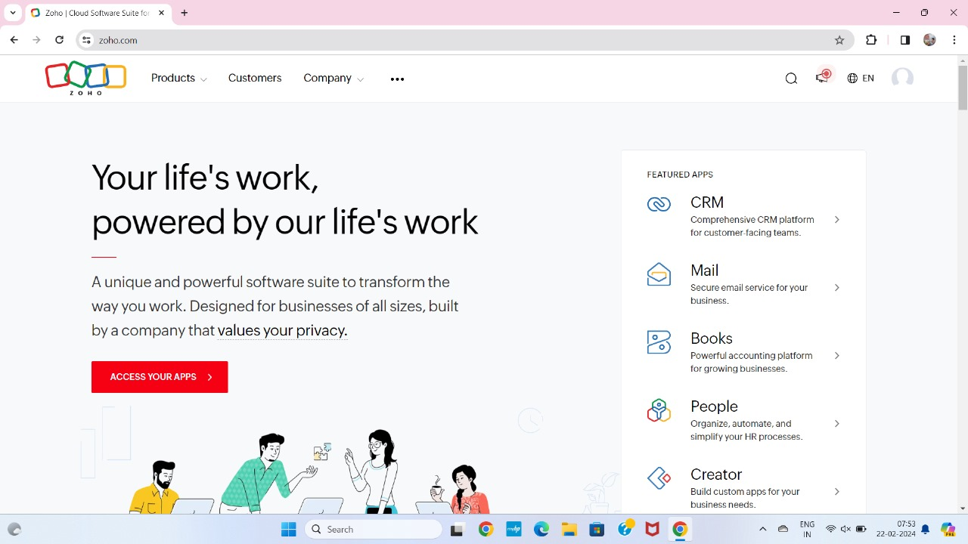

**STEP 2:** LOGIN TO THE ZOHO.COM

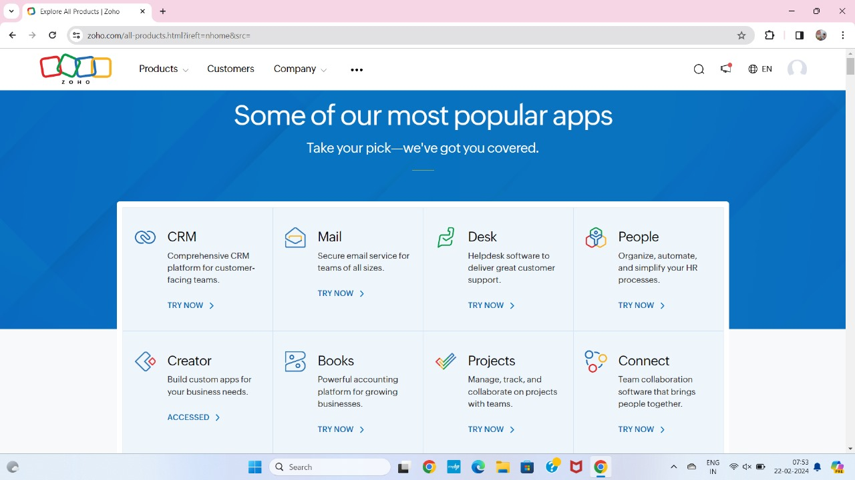

**STEP 3:** SELECT THE CREATE FROM SCRATCH

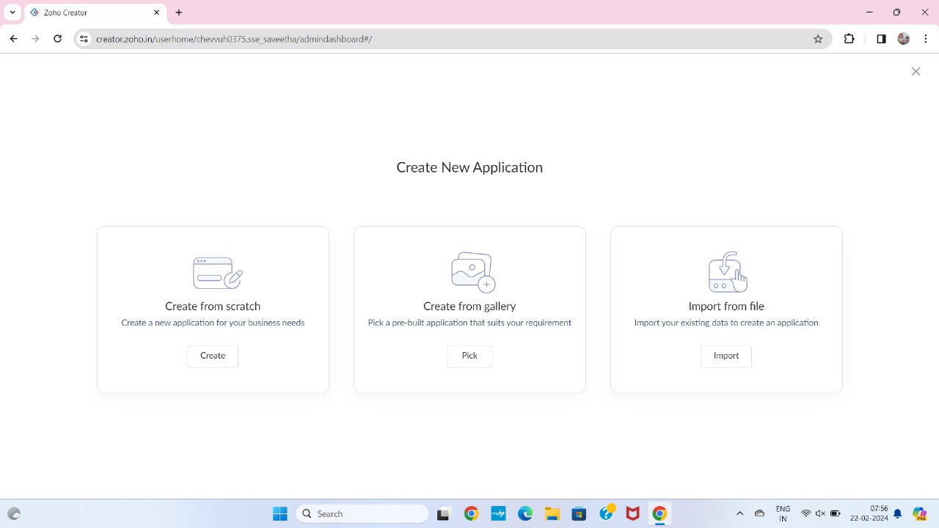

**STEP 4:** SELECT APPLICATION NAME AS LIBRARY BOOK RESERCATION

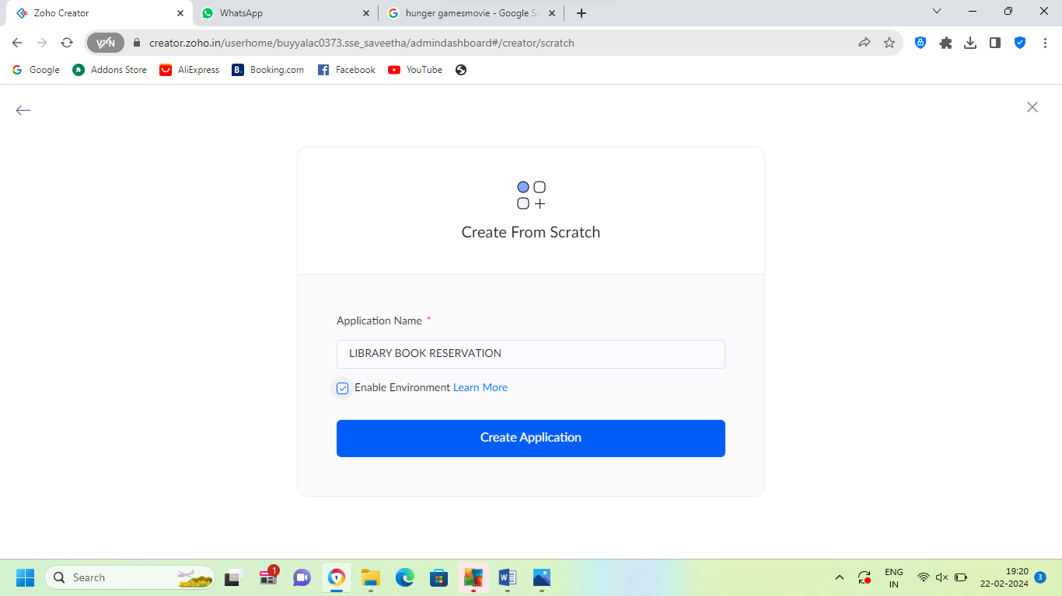

**STEP 5:** CREATE A NEW FORM.

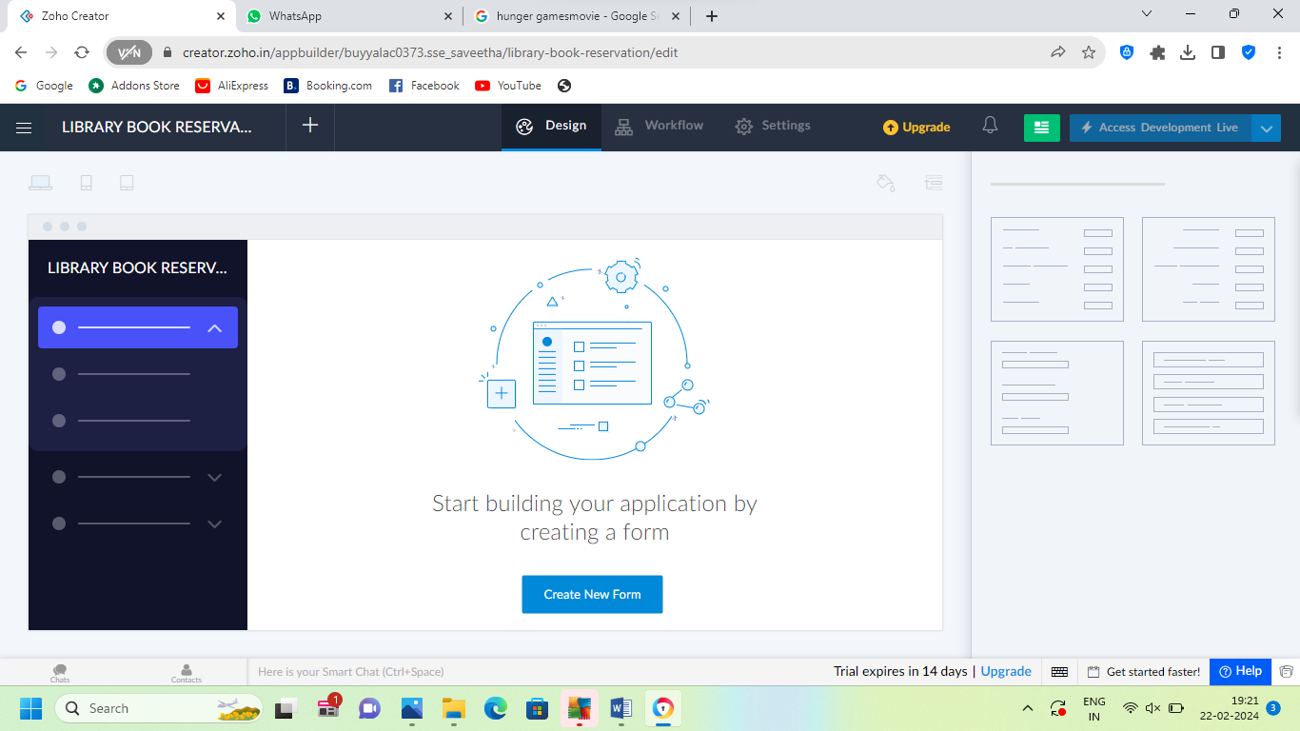

**STEP 6:** SELECT THE BASIC FIELD FORM FROM THE GIVEN BELOW AND DEVELOP APPLICATION

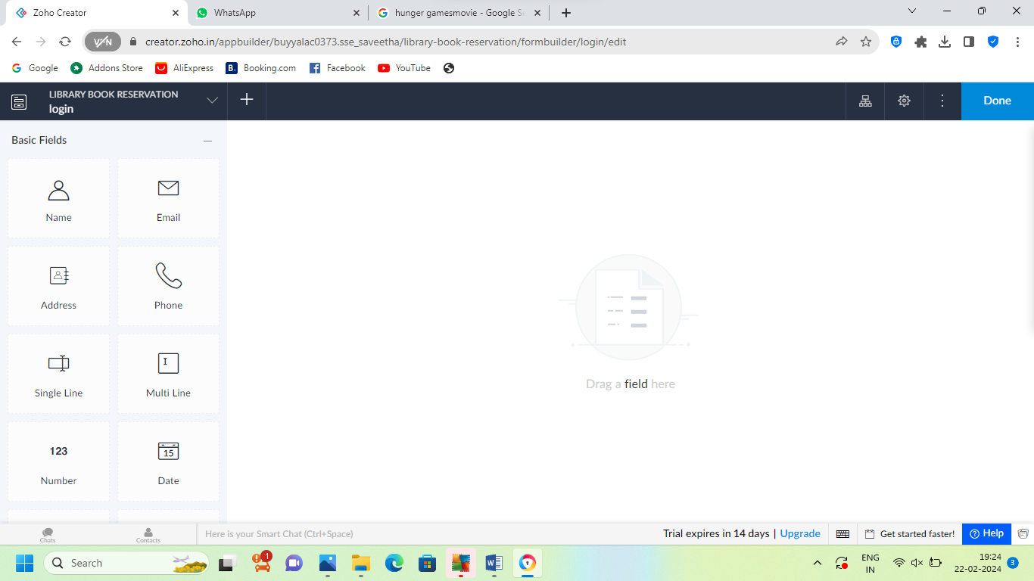

**STEP 7:** THE SOFTWARE HAS BEEN CREATED LOGIN PAGE

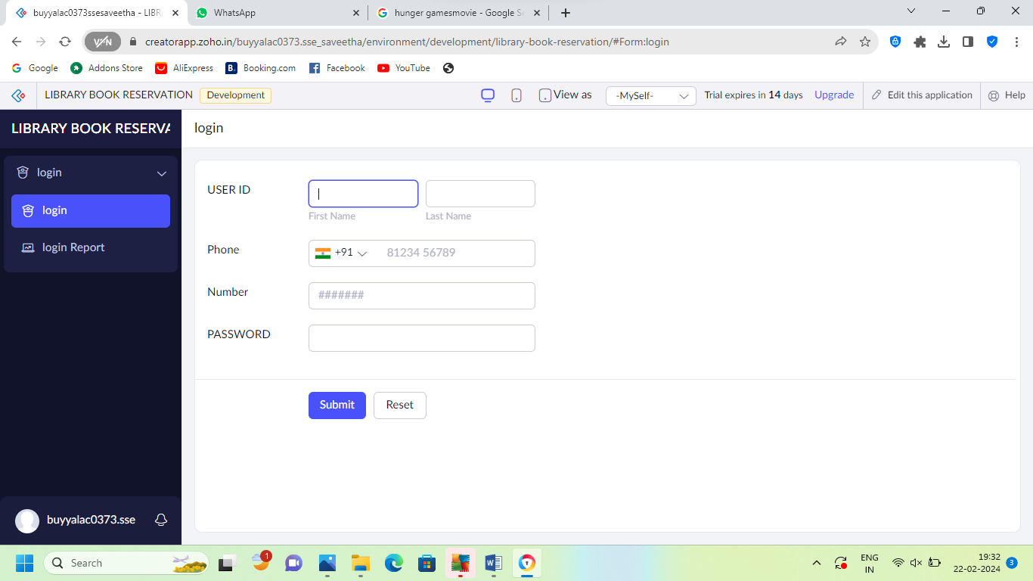

**STEP 8:** THE SOFTWARE HAS BEEN CREATED USER DETAILS.

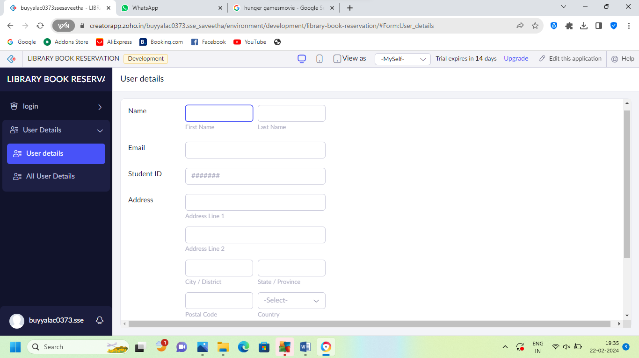

**STEP 9:** THE SOFTWARE HAS BEEN CREATED SEARCHING BOOK FOR

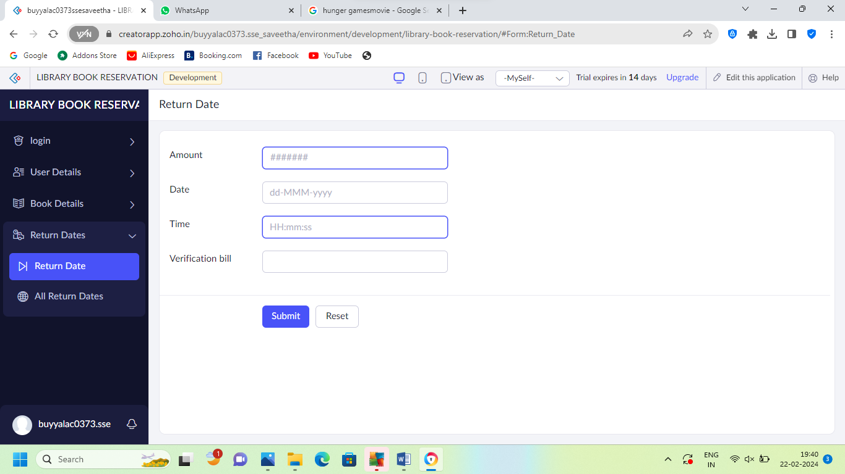

**STEP 10:** THE SOFTWARE HAS BEEN CREATED RETURN DATE OF THE BOOK.

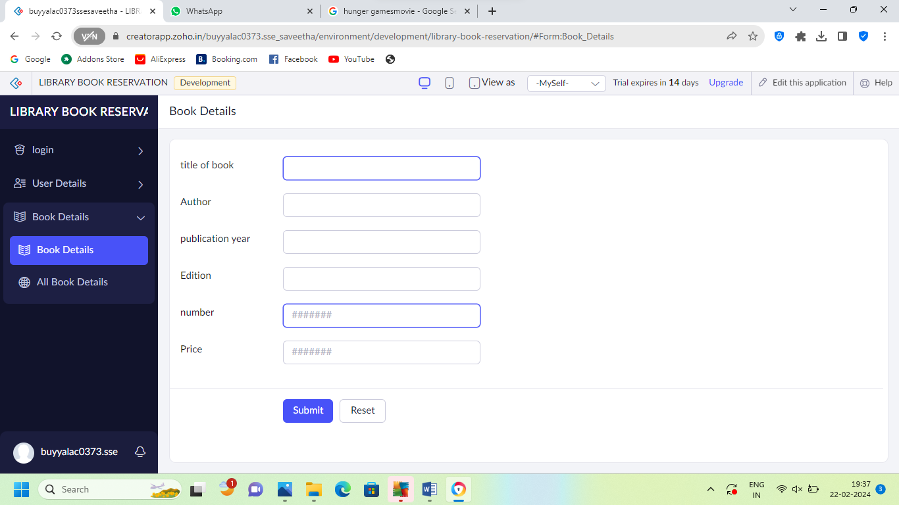

**STEP 11:** THE SOFTWARE HAS BEEN CREATED PAYMENT METHOD.

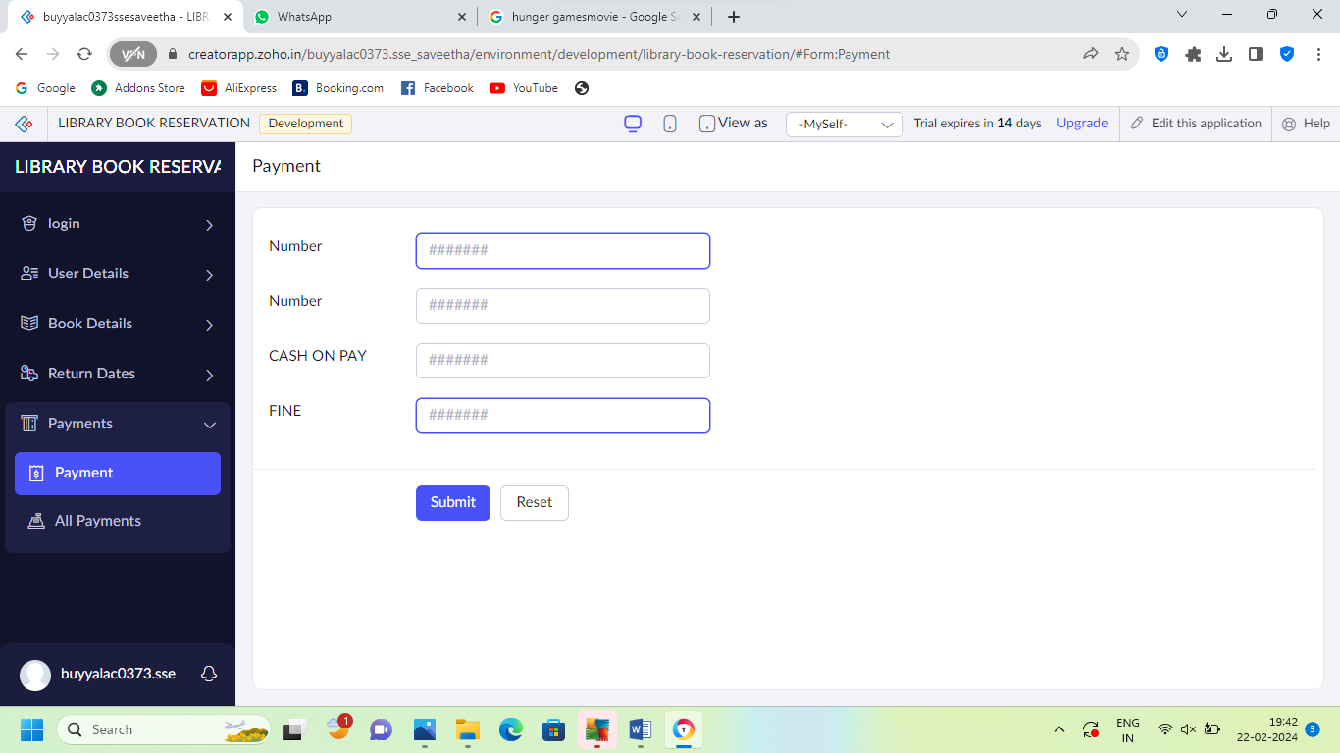

**STEP 12:** THE SOFTWARE HAS BEEN CREATED

